**Cat command:-**

Using cat command, we can display the contents of the file.

In the below image, we have displayed the contents of two files such as **“details”** and **“student”**.

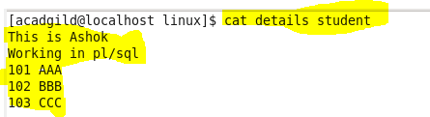

Using the below command (cat >testing), new file will be created called **testing** in the working directory. After created, we have to enter the desired text to store in the file named **testing** and press ctrl+D to store it.

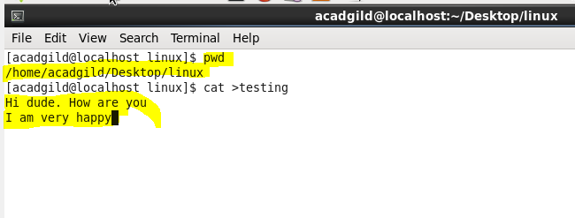

I have pressed ctrl+D after entering the text. The file **testing** with the above content is created.

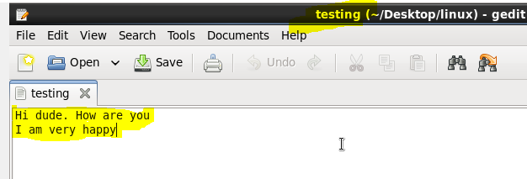

**-n option in cat command:-**

We can display the line numbers using –n option in cat command.

For example,

We have displayed the line numbers for the testing file using –n option in the below image.

